ASSIGNMENT 1
Digital Divide in India: The Role of Gender, Religion, and Sector

Assignment under the course:
Micro and Macro Databases

Bachelor of Science in Analytics and Sustainability Studies (BSASS),
Tata Institute of Social Sciences, Mumbai

_________________

Submitted by:
Krisha Mitra (M2024BSASS015)
17th January 2026

Abstract
India is rapidly digitising its economy and governance systems. Many public services, jobs, education resources, and welfare systems now require some form of digital access. However, digital inclusion is not equal. Most research on the digital divide looks at either gender gaps or differences between rural and urban areas. This report points out that this focus is not enough. In India, religion can influence social norms, people's movement, and how they use technology. These norms may intersect with gender and location (rural or urban) in complex ways. Therefore, this study asks: How do gender, religion, and sector jointly shape digital access and technology use in India?
Using unit-level data from the NSSO 80th Round Modular Telecom Survey, this report examines access to digital devices (mobile and computer), overall access to any digital device, and patterns of digital exclusion. Descriptive statistics, cross-tabulations, chi-square tests, and ANOVA are used to analyse the data. The focus of this study is to determine how the gaps between men and women in different religious sectors differ, and whether urbanisation can reduce the number of women who are being excluded from the workforce due to gender-based discrimination based on their religion.
The analysis of the data shows significant differences in device ownership and access across rural and urban sectors, as well as between men and women. More individuals in rural areas than in urban areas do not own a device, and women are excluded from device use at higher rates than men in both urban and rural areas. This strongly supports the argument made in this report that urbanisation alone will not eliminate gender disparity, but that cultural and social influences on women's access to technology in cities will persist.
The report concludes with recommendations for policies that recognise cultural sensitivities when implementing digital inclusion strategies. This includes providing digital literacy programs specifically designed for women, providing low-cost access to technology through interventions, and creating public digital infrastructure to help to mitigate the barriers women face when accessing technology due to their religion or gender.

Introduction
India is undergoing a major digital transition. People use smartphones every day for communicating, making payments, banking, and learning. Governments are also using more digital platforms for their programs. India’s digital transition has accelerated in recent years, and national survey evidence shows that access to telecom and digital services continues to vary across social groups (Press Information Bureau, 2025). Many services now require online registration, online authentication, or digital documents. These changes are part of broader efforts like Digital India. However, digitisation has its challenges and is not neutral. It can include some groups and exclude others.
Digital access is now a key resource. It influences the ability to access information, claim welfare benefits, apply for jobs, engage in education, and participate in modern markets. Digital access can help people save time and money. It can reduce dependence on intermediaries. It can allow people to work remotely or learn new skills (Antonio & Tuffley, 2014). Therefore, access to devices and digital tools is not just a technical issue. It is linked to inequality and development.
Yet, digital access is not equally distributed. Some people have stable internet, smartphones, and digital literacy. Others do not have any digital device. Even if a device is present in the household, it may be controlled by one person, usually a male member. This means that equal access cannot be assumed. Equal access to the internet cannot be taken for granted. The digital divide goes beyond just having the right infrastructure . It also highlights economic differences, education gaps, and social attitudes.
In India, studies about the digital divide mainly look at two issues: gender and differences between rural and urban areas. Generally, men have more access to digital devices and use them more than women. Urban residents usually have better access and connectivity than those living in rural areas. These points are important, but they may not fully reflect the complexities of Indian society.
Religion and community values also play a significant role. They can shape habits, movement, education, and how people participate in public life. This is especially important for women. In some places, cultural restrictions may limit women's ability to go outside their homes. These restrictions can also affect their use of technology, social media, and communication with men. Sometimes, women may face limits from family members. In other cases, they may internalise norms around "appropriate" behaviour. In such settings, access to technology can become culturally regulated.
This report is based on the idea that digital inequality is social inequality. Technology adoption does not happen in a vacuum. It occurs inside households, communities, and social structures. Therefore, we need to examine digital inclusion through a broader social lens. Religion is one such lens. The report argues that religion may modify gender gaps. For example, in some religious groups, women may face stronger restrictions. In other groups, women may have greater freedom. The patterns may also differ in rural and urban locations.
A key assumption in development thinking is that urbanisation reduces traditional barriers. Cities are seen as spaces of opportunity, freedom, and modernisation. This could imply that gender gaps in digital access should reduce in cities. But this may not always be true. In many cases, cultural norms travel with people. Families carry norms into urban settings. Therefore, women may still face control or restrictions. The digital divide in India is not only about access to technology but also about exclusion from opportunities and participation in society (Singh & Singh, 2021).
This creates the core storyline of this report:
Urbanisation does not automatically reduce gender inequality. Religious and cultural norms continue to shape women's digital access, even in cities.
Research Question
This report revolves around one central research question:
How do gender, religion, and sector (rural/urban) jointly shape digital access and technology use in India, and does urbanisation weaken gender gaps equally across religious groups?
This research question is impactful because it moves beyond routine digital divide studies that focus only on gender or rural–urban differences. Instead, it brings culture and space into the analysis by examining how religion and sector shape digital access along with gender. It also allows the study to develop an interaction-based explanation, showing how gender gaps may change across different religious groups and across rural and urban areas. Finally, the question is strongly policy-relevant because it helps identify which groups face the highest digital exclusion and why, which can guide more targeted and inclusive digital policy interventions.
Objectives of the Study
The objectives are:
- To measure patterns of access to digital devices (mobile, computer, both, or none) in rural and urban India.
- To examine gender gaps in access to any digital device in rural and urban areas.
- To analyse differences in device access across religious groupings.
- To assess whether the gender gap is modified by religion and sector, highlighting intersectional exclusion.
- To draw micro–macro conclusions on how social norms influence technology adoption, and to derive policy recommendations.
Why this study matters
This study is important because it shows how digital inclusion relates to cultural inequality. It can help shape policies. Many policies assume that simply providing internet access will lead people to use technology. However, there are also social barriers to consider. If we don't address these social issues, digital systems may end up excluding some people.
This issue is especially important for women. Access to digital tools is tied to financial opportunities, education, safety, and empowerment. If women remain digitally excluded, gender inequalities may worsen (Dubey et al., 2024). So, we should see digital inclusion as an issue of gender justice and social justice.
Literature Review and Conceptual Framework
This section explains how this report connects to key ideas in digital divide research.
Digital Divide: Beyond "Access"
Early research on the digital divide focused on whether individuals had internet access or device ownership. This is often called the "first-level digital divide". Later research suggested that digital inequality also exists in usage, skills, and outcomes. This led to second-level (skills and usage patterns) and third-level (benefits gained from digital use) divides.
This framework matters because:
- A person may have a phone but may not use it for meaningful tasks.
- A person may have access but may not control the device.
- A person may have access but may face social surveillance.
Thus, the digital divide is not only technical. It is social.
Gender and Digital Inequality
Many studies showed that the digital divide disproportionately affects women because they generally have lower access to digital resources (such as smartphones, internet connectivity, computers, and digital literacy). This disparity between men and women is caused by multiple socio-economic factors. For example, in many regions of India, women tend to have lower levels of education than men, making them less confident and less able to use technology. Furthermore, women tend to participate less in the workforce, leading to lower incomes and, in turn, reducing their ability to purchase devices or subscribe to internet services. Additionally, due to the traditional gender roles in most households, women typically have less authority when it comes to financial decision-making within the family unit, meaning that when it comes to purchasing devices and using digital services, men are likely to be prioritised. Moreover, women tend to carry a greater burden of unpaid caregiving and household duties, reducing their opportunities to learn or regularly use digital technologies. Socially constructed gender expectations strengthen this inequality, as many families believe that women should have limited exposure to the outside world through digital media. In some instances, women experience safety concerns and fears of harassment while utilising digital and communication technologies, and in many households, the monitoring of women's use of electronic devices is prevalent, with many households having to share devices rather than having personal device ownership.

Religion, Norms, and Technology Use
In India, religion influences how people live and behave every day. It affects what men and women can do at home and in public. For women, this often means they have less freedom to go out or make their own choices.
In some homes, girls might not be allowed to have their own mobile phones, or their phone use might be closely monitored. Women may also face more rules about using social media or the internet, even if they have access to devices. Because of this, families often focus more on what men need in terms of technology, making it harder for women to stay connected.
For example, in December 2025, reports showed that a community panchayat decision in Gazipur village in Rajasthan's Jalore district restricted daughters-in-law and young women in around 15 villages from using smartphones with cameras. Women were reportedly allowed only keypad phones, and even carrying phones to social events or neighbours' houses was discouraged. School-going girls were said to be allowed to use a phone for a limited time at home for studies (The Hindu,2026). This incident highlights how digital access is not only affected by income or infrastructure, but also by social control and community norms, especially for women. It supports the idea that, even when technology is available, women's access can still be restricted by cultural expectations and concerns about "appropriate" behaviour.
Religion works together with other factors, such as social class, education, and where people live. For example, digital access can differ between cities and the countryside. Religion can influence digital behaviour by shaping identity, acceptable communication, and community norms around technology use (Uppal, 2017). To really understand why there is a gap in technology use between men and women in India, we must consider how religion, gender, and other factors all connect.
Sector (Rural/Urban) as "Space"
Cities usually have better network infrastructure, easier access to device markets, higher income opportunities, and greater exposure to education.
So one might expect that urban women should have better digital access. But cultural norms may remain stable. Therefore, urban advantage may exist, but may not remove gender gaps. This is a key theoretical tension.
Conceptual Model
This report is based on a simple but strong conceptual model. It assumes that gender influences digital access, meaning that men and women do not have equal chances of owning or using digital devices. However, this relationship does not remain the same for everyone. It is shaped by religion and sector (whether a person lives in a rural or urban area). Therefore, the effect of gender on digital access is not constant. Instead, gender gaps can widen or narrow depending on the religious group and the rural–urban context in which a person lives (Laskar, 2023).
Data and Methodology
Dataset
This study uses the NSSO 80th Round Modular Telecom Survey.
The NSSO telecom survey is relevant because it captures:
- access to digital devices,
- patterns of technology use,
- and reasons for non-use (digital exclusion).
The sample is large, which supports subgroup analysis. This is necessary for an interaction-based study like gender × religion × Sector.
Key Variables
The study uses these major variables:
Social Variables
- Gender (male/female/transgender)
- Religion groupings
- Sector (rural/urban)
Digital Variables
- Access to different digital devices (none/mobile/computer/both)
- Access to any digital device (binary)
- Reasons for non-use (Reason)
- Technology use indicators (use_mobile, use_comp, b4q*)
These variables allow a strong analysis of:
- access
- exclusion
- and cultural constraints.
Analytical Strategy
This report uses:
Descriptive analysis: To report overall levels and compare groups.
Cross-tabulation: To compare access across sector, gender, and religion.
Chi-square tests: To test whether associations are statistically significant.
ANOVA tests: To test differences in means of access indicators across groups (where applicable).
These techniques meet the assignment expectation of going beyond simple description by applying inferential tests and interpreting results.
Derived Indicators
For this assignment, a few derived indicators were created in SPSS, such as:
- acc_any : dig_acc > 0
- dig_acc : (use_mobile_n = 1) + 2*(use_comp_n = 1)
- rel_gen_exclusion : gen_n = 2 AND acc_any = 0
- urb_benefit : sector_n = 2 AND acc_any= 1
- urb_gen_gap : sector_n = 2 AND gen_n = 2 AND acc_any = 0
First, dig_acc was created as a combined digital access index using the expression (use_mobile_n = 1) + 2(use_comp_n = 1). This variable integrates mobile and computer access into one measure and produces values from 0 to 3, where 0 indicates no digital access, 1 indicates mobile-only access, 2 indicates computer-only access, and 3 indicates access to both mobile and computer, thereby capturing not only whether a person has access, but also the type/quality of access.
Next, acc_any was derived from dig_acc using the condition dig_acc > 0. This creates a simple binary indicator representing whether an individual has any digital access at all. In this variable, 1 means the respondent has at least one device (mobile or computer), while 0 indicates complete digital exclusion, making it useful for clean comparisons of access gaps across gender and sector using stacked bar charts and crosstabs.
Further, rel_gen_exclusion was developed using the expression gen_n = 2 AND acc_any = 0, which identifies women who are digitally excluded (i.e., female respondents who have no access to any digital device). Although religion is not directly included in the condition, this indicator becomes religion-sensitive when it is analysed across religion_grp using cross-tabulations and religion-wise charts, allowing the study to compare exclusion levels among women across different religious groups.
In order to specifically assess whether individuals benefit from urban infrastructure, urb_benefit was constructed as sector_n = 2 AND acc_any = 1. This variable highlights those respondents who live in urban areas and also have digital access, representing the group that actually gains from urban digital opportunities. The mean of this variable across gender or religion can be interpreted as the proportion of each group that successfully converts urban location into digital access.
Finally, to capture the most critical inequality group in the report, urb_gen_gap was generated using sector_n = 2 AND gen_n = 2 AND acc_any = 0, which identifies urban women who remain digitally excluded. This indicator is important because it supports the argument that urbanisation improves overall access but does not fully eliminate gender inequality, as some women remain excluded even in urban settings.
Results
Digital device access differs sharply by sector
Access to different digital devices * Sector Crosstabulation
% within Access to different digital devices
 |  | Sector |  | Total
 |  | Rural | Urban
Access to different digital devices | No Device | 69.8% | 30.2% | 100.0%
 | Mobile | 60.9% | 39.1% | 100.0%
 | Computer | 100.0% |  | 100.0%
 | Both | 38.9% | 61.1% | 100.0%
Total |  | 57.9% | 42.1% | 100.0%

Chi-Square Tests
 | Value | df | Asymptotic Significance (2-sided)
Pearson Chi-Square | 5516.679ª | 3 | .000
Likelihood Ratio | 5500.423 | 3 | .000
Linear-by-Linear Association | 5492.664 | 1 | .000
N of Valid Cases | 136937
a. 2 cells (25.0%) have expected count less than 5. The minimum expected count is .84.
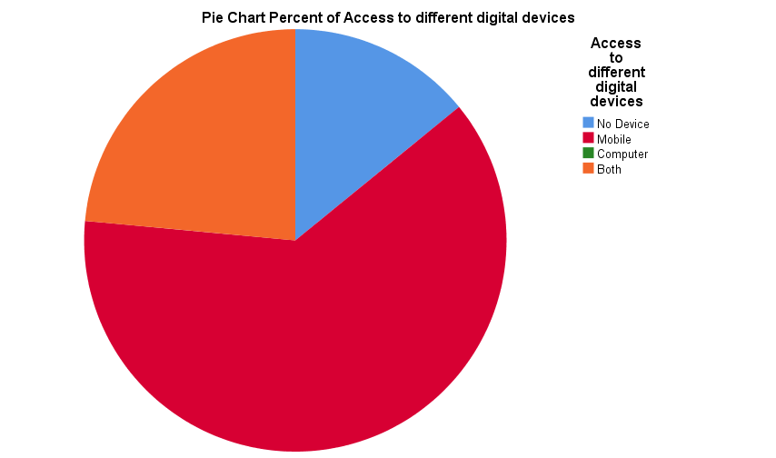
The cross-tabulation shows strong sector differences in access to digital devices.
Key result:
- For people with no device, 69.8% are rural, and 30.2% are urban.
- For those with mobile phones, 60.9% are rural, and 39.1% are urban.
- For those with both mobile and computer, 38.9% are rural, and 61.1% are urban.
This pattern is expected. Urban areas have greater connectivity and higher incomes. Computers are also more common in cities. The urban advantage is visible in the "both" category, where most people are urban.
Importantly, the chi-square test is extremely significant (Pearson Chi-square = 5516.679, df=3, p<.001).
This means device access is strongly associated with the sector. The difference is not random. It is a real structural difference.
Interpretation:
Many people in rural India still lack access to digital technology. Some do not own any devices, which limits their ability to use online services. This means that any policy relying only on digital systems could leave rural residents out, unless there is offline support available.
Gender inequality is present in both rural and urban areas
Gender * Access to any digital device * Sector Crosstabulation
% within Gender
Sector |  |  | Access to any digital device |  | Total
 |  |  | Has no digital device | Has a digital device
Rural | Gender | male | 13.7% | 86.3% | 100.0%
 |  | female | 23.4% | 76.6% | 100.0%
 |  | transgender | 23.5% | 76.5% | 100.0%
 | Total |  | 18.5% | 81.5% | 100.0%
Urban | Gender | male | 8.1% | 91.9% | 100.0%
 |  | female | 14.1% | 85.9% | 100.0%
 |  | transgender | 15.8% | 84.2% | 100.0%
 | Total |  | 11.0% | 89.0% | 100.0%
Total | Gender | male | 11.3% | 88.7% | 100.0%
 |  | female | 19.5% | 80.5% | 100.0%
 |  | transgender | 20.5% | 79.5% | 100.0%
 | Total |  | 15.3% | 84.7% | 100.0%
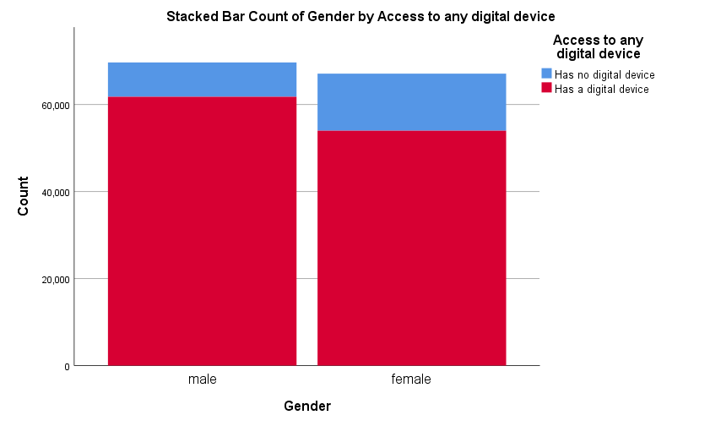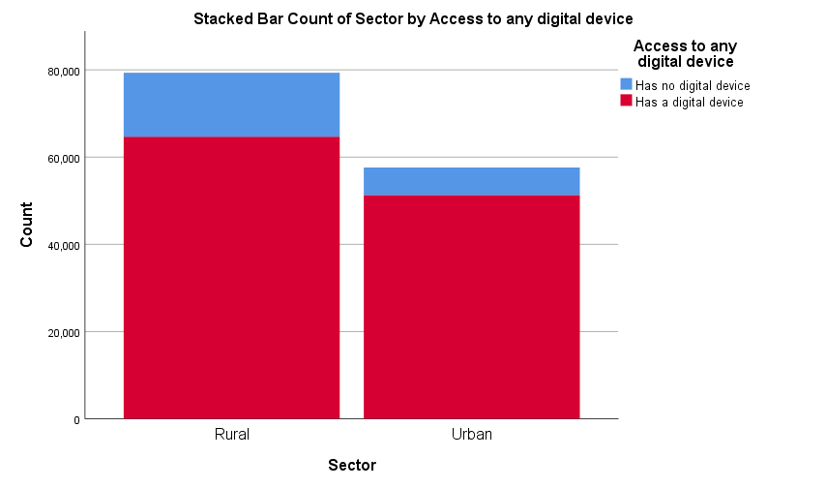
The gender × Access × Sector table provides one of the most important findings of this report.
Rural
- Males with no digital device: 13.7%
- Females with no digital device: 23.4%
- Transgender with no digital device: 23.5%
This means rural women have a much higher exclusion rate than rural men.
Urban
- Males with no digital device: 8.1%
- Females with no digital device: 14.1%
- Transgender with no digital device: 15.8%
Urban women also show higher exclusion than urban men.
Total (All sectors):
- Males with no device: 11.3%
- Females with no device: 19.5%
- Transgender with no device: 20.5%
These results confirm that the digital divide is not only rural–urban. It is also gendered. Even in cities, women have lower digital access.
Important insight:
Urbanisation reduces overall exclusion but does not eliminate gender inequality. The female disadvantage remains.
This directly supports:
Urbanisation does not automatically reduce gender inequality.
Gender gap remains strong even in cities

The gender gap in digital exclusion remains strong even in urban areas. When we compare women and men without digital devices, we see that the rural gender exclusion gap is 9.7 percentage points (23.4% for females compared to 13.7% for males). In urban areas, the gap becomes slightly smaller but still remains high at 6.0 percentage points (14.1% for females compared to 8.1% for males). This shows that urban living does provide some advantage in reducing overall digital deprivation, but it does not remove gender inequality. Gender-based barriers continue even in cities, and these barriers may be linked to household-level decision-making, control over devices, and persistent social restrictions on women's technology use. This finding strengthens the main argument of the report. It is not only that women are digitally excluded, but that women experience digital exclusion differently depending on the cultural and social context in which they live.

The strength of the association is statistically significant.
Symmetric Measures
Sector |  |  | Value | Asymptotic Standard Error | Approximate T^{b} | Approximate Significance
Rural | Interval by Interval | Pearson's R | -.125 | .003 | -35.463 | .000
 | Ordinal by Ordinal | Spearman Correlation | -.125 | .003 | -35.542 | .000
 | N of Valid Cases |  | 79329
Urban | Interval by Interval | Pearson's R | -.096 | .004 | -23.163 | .000
 | Ordinal by Ordinal | Spearman Correlation | -.096 | .004 | -23.192 | .000
 | N of Valid Cases |  | 57608
Total | Interval by Interval | Pearson's R | -.114 | .003 | -42.375 | .000
 | Ordinal by Ordinal | Spearman Correlation | -.114 | .003 | -42.452 | .000
 | N of Valid Cases |  | 136937
a. Not assuming the null hypothesis.
b. Using the asymptotic standard error assuming the null hypothesis.
c. Based on normal approximation.

The symmetric measures further confirm that gender is strongly associated with access to digital devices. The Pearson correlation coefficient between the two sectors is negative and statistically significant. In the rural sample, the Pearson coefficient is -0.125 (p<0.001), and in the urban sample, it is -0.096 (p<0.001). The median of the total sample for the Pearson coefficient was -0.114 (p<0.001). The negative association suggests that women have fewer opportunities than men to access devices.

Also, the ANOVA test between access and gender is significant:
F(2,136934) = 901.792, p<.001
ANOVA Table
 |  |  | Sum of Squares | df | Mean Square | F | Sig.
Access to any digital device * Gender | Between Groups | (Combined) | 231.233 | 2 | 115.616 | 901.792 | .000
 | Within Groups |  | 17555.934 | 136934 | .128
 | Total |  | 17787.166 | 136936

This supports the conclusion that gender differences are not small or random.

ANOVA Table
 |  |  | Sum of Squares | df | Mean Square | F | Sig.
Religion Groupings * Access to any digital device | Between Groups | (Combined) | 141.515 | 1 | 141.515 | 319.358 | .000
 | Within Groups |  | 60678.916 | 136935 | .443
 | Total |  | 60820.431 | 136936
Religion shapes digital access.

The ANOVA results show that religion is significantly associated with access to any digital device. The test result is significant (F = 319.358, p < .001), indicating that differences in digital access across religious groups are not random. This finding supports the inclusion of religion as a primary analytical variable, not just an ancillary characteristic, when examining the digital divide in India. In other words, Religion is a primary determinant of digital access/usage outcomes in India. The implications of this are that Religion does not in itself create exclusion; rather, it may represent an articulation of how broader social issues, including cultural attitudes, educational patterns, geographic dispersion, and socio-economic status, negatively impact or restrict Digital Access/Usage Opportunities for certain groups or individuals. Additionally, Religion may serve as a marker of how some families have different expectations or limitations on women's participation within their home-family structure. Thus, we must consider Religion as an essential element of Social Context that not only informs Digital Access/Usage Opportunities but also determines how Digital Inequality is experienced across different communities.
Urban benefit is not gender-neutral.
ANOVA Table
 |  |  | Sum of Squares | df | Mean Square | F | Sig.
Gender * Urban Benefit | Between Groups | (Combined) | 34.786 | 1 | 34.786 | 137.768 | .000
 | Within Groups |  | 35394.411 | 140179 | .252
 | Total |  | 35429.197 | 140180

The ANOVA test shows "Gender × Urban Benefit" is significant:
F = 137.768, p<.001
Even without seeing the complete operational definition of "Urban Benefit," the significance suggests that:
- The advantage of being urban is not equal for all genders,
- and the urban context interacts with gender.
This aligns perfectly with the report's central question: whether urbanisation weakens gender gaps equally across groups.
Gender × religion × Sector: The core interpretive result
Although the outputs shared so far do not yet include a full three-way crosstab table, the results clearly support the idea that digital access in India is shaped by the combined effect of gender, religion, and sector. The results suggest that there are differences in access to technology between rural and urban locations as a result of sector involvement. Additionally, this research highlighted the differences between males and females within the sector; females tend to have a higher rate of exclusion from digital devices than males, regardless of their rural or urban setting. This research also demonstrates that religion is an important factor in terms of access to digital devices, which implies that community context and cultural norms affect digital inclusion. The findings indicate that while benefits may accrue to those living in urban areas, they are not equally shared across genders; therefore, simply living in an urban area does not eliminate gender inequality. The findings taken together present a clear narrative regarding digital access in India, which reveals a social geography of inequality, with persistent gender gaps across all physical spaces and significant differences in access distribution by religious grouping. Thus, it is evident that if we are to develop policies for digital inclusion, it is essential to consider the intersection of gender, religion, and space rather than developing general or uniform approaches.
Discussion: Connecting Micro Evidence to Macro Debates
This section links the results to broader processes.
Why urbanisation does not erase gender inequality
A common assumption in development thinking is that urban life leads to modern attitudes and reduces traditional inequalities. Cities usually provide better opportunities, such as more jobs, better education, greater exposure to public spaces, and higher personal autonomy. Because of these advantages, it is often expected that women in urban areas will have more equal access to digital devices and technology. However, the results of this study show that a clear gender gap continues to exist even in cities. Female device exclusion remains high at 14.1%, while male exclusion is much lower at 8.1%. Urbanisation may increase total levels of access, but it does not eliminate the barriers faced by women as a result of their gender. Urbanisation also appears to allow families greater control over devices and technology used by their members and, therefore, to continue regulating the manner in which women use technology. Digital access may not always be a priority for women in urban areas, even if they reside in urban households. Therefore, gender inequality in digital access cannot be explained only through infrastructure and location. It is also closely connected to social power within families and communities.
Religion as a modifier of gender norms
Religion matters because it relates to:
- community structures,
- family expectations,
- and women's mobility norms.
In some contexts, women's phone use may be seen as unsafe or inappropriate. Families may fear social judgment. They may also fear women communicating freely. In such situations, technology access becomes linked to control.
This is why religion is important. It shapes the "rules" around women's behaviour. These rules may persist even in cities.

Digital inequality is cultural inequality.
A key contribution of this report is that it treats digital exclusion as a cultural issue. Most studies treat it as economic or infrastructural. But culture matters too. Even if a household can afford a device, the device may not be given to women.
This creates an important micro–macro implication: Digitisation can deepen inequality if access is socially controlled. Women may lose out on digital welfare systems, and labour markets may reward digitally connected groups.
Policy implication: One-size-fits-all digital inclusion will fail
Many digital inclusion programmes are based on the assumption that if devices are distributed and connectivity is improved, people will automatically start using digital services equally. However, the results of this study suggest that such a one-size-fits-all approach will not work. Even when urban infrastructure is better, the gender gap in digital access still remains, showing that women continue to face problems. The findings also show that digital access differs across religious groups, which suggests that cultural norms and community contexts may influence who gets to use technology and how freely they can use it. This means that a sector alone, such as shifting from rural to urban areas, does not fully solve inequality. Therefore, digital inclusion policies need to be more targeted and socially aware. Policy efforts should support women's independent access to devices, design digital literacy programmes in a culturally sensitive way, and create safe and accessible spaces where women can learn and use digital tools without fear or restriction. Community-level support and local outreach are also important so that inclusion efforts can address real social barriers, not only technical ones.
Conclusion and Policy Implications
This report examined digital access in India using the NSSO 80th Round Modular Telecom Survey. The main purpose was to understand how digital access is shaped by gender and rural–urban differences, also by religion and social norms. Most studies on the digital divide treat gender and location separately. In contrast, this report used an intersectional approach and focused on the combined effect of gender, religion, and sector. The central research question asked whether urbanisation reduces gender inequality equally across religious groups. The findings clearly suggest that it does not.
Given the scale of India’s telecom sector and the policy focus on connectivity and service delivery, closing gendered and community-based access gaps should be treated as part of mainstream telecom inclusion policy (Telecom Regulatory Authority of India, 2026). The results show that rural–urban differences remain important, especially in access to advanced digital resources such as computers. Rural individuals are more likely to have no access to any digital device, and urban individuals are more likely to have access to both mobile and computer devices. This shows that infrastructure, market access, and economic opportunity still matter for digital inclusion. The most important finding of the report is that gender inequality is present in both rural and urban areas. Women are more likely than men to lack access to any digital device, and this gap is noticeable even in cities. While urbanisation reduces overall hardship, it does not eliminate gender-based exclusion. This shows that access to technology depends not just on having internet and money. It is also influenced by power within the household, mobility, and cultural norms.
There is a demonstration of a clear relationship between religion and the way women access technology. This is important as religion can often serve as an important source of norms, social expectations, and lifestyle patterns within a specific community, which may affect the way that women have access to or control over using technology. The report does not state that religion is a cause of digital exclusion of women; rather, religion may provide a social context for the ways that gender roles and restrictions are applied. When looking at the information regarding the gender and sector, it is clear that digital inclusion in India is defined by a geography of social inequality. Women continue to experience barriers to access due to a combination of other barriers, such as being poor or living in rural areas, as well as due to gender roles within their respective cultures and communities. These findings hold significant implications for how we develop policies towards increasing digital inclusion. Many digital inclusion policymakers believe that simply increasing available broadband internet and distributing devices will result in equitable use of technology.
The evidence from this report suggests that such approaches are incomplete. Digital access is not only an individual choice. It is often a household decision, and for women, it can be a socially controlled resource. Policymaking needs to take into account the distinct barriers that women face when it comes to accessing digital technology. For instance, policies must incorporate ways to increase women's access to devices, as well as develop and implement digital literacy programs that specifically include women, and create safe spaces where women can learn how to utilise digital tools. Policies should also be created keeping in mind the cultural and social context in which women live. In regions/countries where women are prohibited from using technologies, community-based approaches, local facilitators, and outreach that respect cultural differences will likely need to be employed.
Furthermore, as India continues to develop, digitise and modernise its processes and systems, it is important to view digital exclusion as a contributor to social exclusion. If welfare services, education, and job opportunities increasingly shift online, groups that remain digitally excluded may face greater inequality. In this sense, digital access should be understood as a key capability needed for participation in modern society. Ensuring digital inclusion is therefore not only a technological or economic goal. It is also a gender justice and social justice goal.
This report also has strong publication potential because it provides a culturally grounded and intersectional explanation of digital inequality, which is still rare in the Indian digital divide literature. Future research can build on this study by using interaction-based regression models and creating a detailed index to measure digital access and use. It can also look into how religion interacts with other identity factors like caste and education. More studies should find out if differences arise mainly from affordability, digital literacy, or social restrictions. Overall, this study strongly shows that urbanisation alone will not solve gender-based digital exclusion. To achieve real digital inclusion, India needs policies that close infrastructure gaps and challenge social norms. This way, technology can promote equality rather than create more inequality.
Declaration of AI Usage Statement
ChatGPT was used to improve sentence structure and organise sections according to the required format. AI was not used to generate survey data, perform statistical analysis, or fabricate results. All AI-assisted content was verified and edited before final submission.
References
Antonio, A., & Tuffley, D. (2014). The gender digital divide in developing countries. Future Internet, 6(4), 673–687.
https://doi.org/10.3390/fi6040673
Dubey, A., Sinha, A., & Raj, A. (2024). Navigating the digital divide in India: A comprehensive guide. Humanities & Social Sciences Reviews, 12(2), 16–24. https://doi.org/10.18510/hssr.2024.1223
Singh, S., & Singh, G. A. (2021). Assessing the impact of the digital divide on Indian society: A study of social exclusion. Research in Social Change, 13(s1), 181–190. https://doi.org/10.2478/rsc-2021-0018
Laskar, M. H. (2023). Frontiers in Sociology Title: Examining the emergence of digital society and the digital divide in India: A comparative evaluation between urban and rural areas
DOI: 10.3389/fsoc.2023.1145221
Uppal, C. (2017). Digital divide, diasporic identity and a spiritual upgrade. In M. Balaji (Ed.), Digital Hinduism: Dharma and discourse in the age of new media (pp. 129–148). Lexington Books.
Dutta, A. (2026, January 9). Women in Rajasthan’s Jalore are almost disconnected
https://www.thehindu.com/news/national/rajasthan/rajasthan-jalore-women-smartphone-ban-chaudhury-community/article70477467.ece
Telecom Regulatory Authority of India. (2026). TRAI annual report 2024–25 [Annual report]. https://www.trai.gov.in/sites/default/files/2026-01/Annual_Report_06012026.pdf
Press Information Bureau. (2025, May 29). Results of Comprehensive Modular Survey: Telecom, 2025 (January–March 2025) [Press release]. Government of India. https://www.pib.gov.in/PressReleasePage.aspx?PRID=2132330
Ministry of Statistics and Programme Implementation. (2025). Comprehensive Modular Survey: Telecom (NSS 80th Round, January–March 2025) [Data set]. Government of India.

